Activity 2.1: Drawing a hexagon
Program the cat to draw a hexagon.
Use these blocks: The internal angles of a hexagon are 120 degrees:
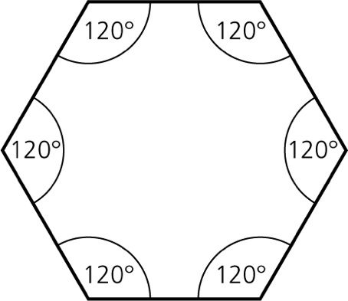
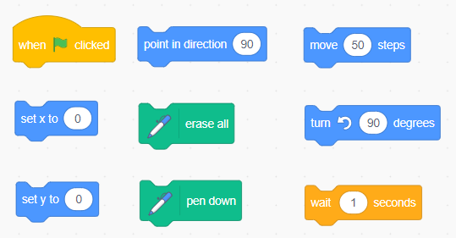

Don’t forget to screenshot your blocks and paste the screenshot into your evidence document.
Extension activity 1
Your solution contains repeated code. Can you use the ‘repeat’ block to reduce the number of blocks in your code and still end up with a hexagon?
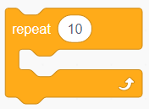
Remember to screenshot your blocks and paste the screenshot into your evidence document.

Extension activity 2
Can you refine your code so that the cat draws two hexagons? What is the fewest number of blocks you can add to your program to achieve this?
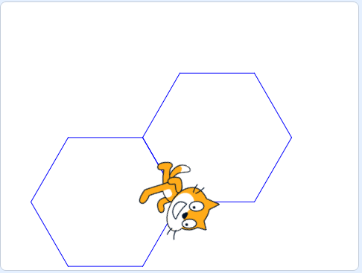
Remember to screenshot your blocks and paste the screenshot into your evidence document.

